Activate Open Item Management For GL Account | SAP FICO

To activate OPEN ITEM MANAGEMENT FOR GL ACCOUNT in SAP

There is two possibility or environment where we have to activate any GL for Open Item Management.

* **If postings are not made into the GL Account : FS00**
* **if postings are already made into the GL : FAGL_ACTIVATE_OP**

Here we will look into the 2nd one where postings are already made. And in this case we can activate Open Item Management for all existing entries in GL with transaction **FAGL_ACTIVATE_OP**.

Screen Layout of TCode **FAGL_ACTIVATE_OP**

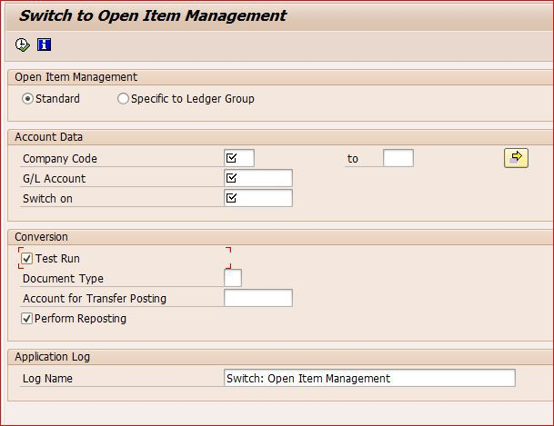

In this Screen we have to enter the **Company Code** and the **GL Account** for which we have to activate the open item management. And will provide **Switch on**date ,a date older than the first line item posting date in the GL Account.

We will see all this with an example.

**Step 1 :** TCODE : FS00

In this Tcode you can see that for our GL “345030” Open Item Management is Not Checked and only Line Item Display is checked.

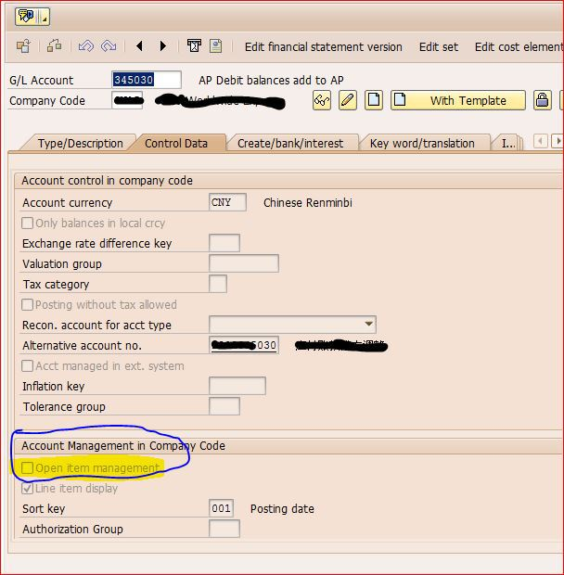

**Step 2** :- TCode : FBL3N for GL 345030

Let us assume that several line item postings are already made to GL account, which was not maintained as Open item Managed and now we want to activate open item management for all existing line items.

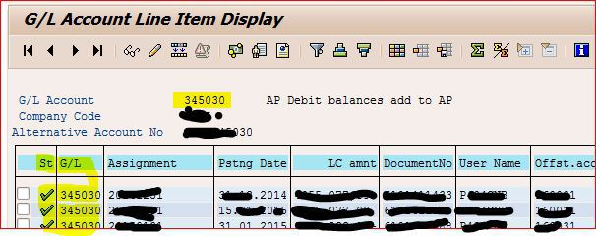

**Step 3** :- TCODE : **FAGL_ACTIVATE_OP**

And now business would like to activate all above line items as open with using of above program.

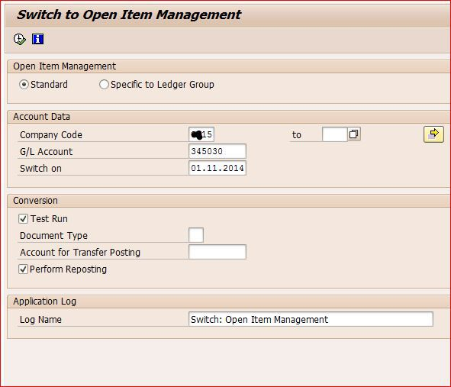

Enter “**Company Code**” and “**G/L Account**” (in our case 345030), which is to be activating as Open Item Management and “**Switch on**” date should be before the first line items was posted with respect to above GL. In this case my first document posted on 22.11.2014 ,that means switch on date should be earlier than 22.11.2014, for which I have taken 01.11.2014 in above screen shot.  “**Document Type**” and  “**Account for transfer posting**” is not required. Don’t Forget to check “**Test Run**” and “**Perform Reporting**“.

Now when you execute with test run checked you will get below message screen:

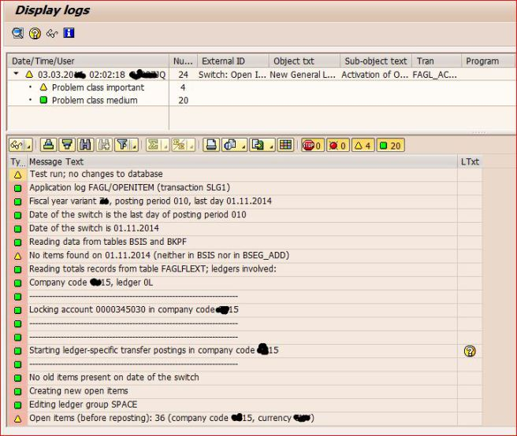

Now if you don’t find any **Error Message**(ie message with Red dot ) you can go back, Remove **Test Run** and Execute the transaction and the Line Items will be activated for Open Item management.

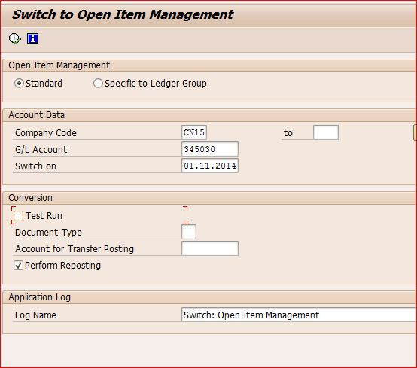

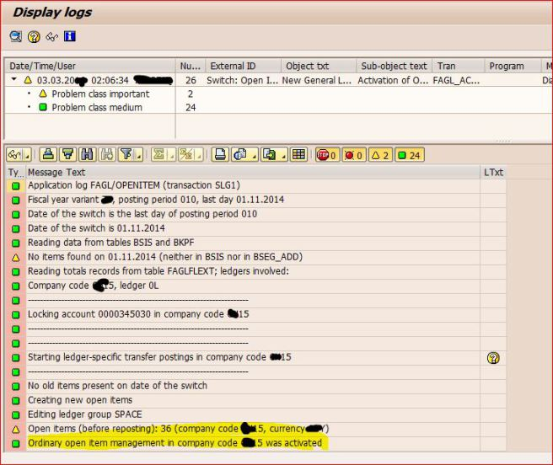

Now if you go to FBL3N and FS00 you can see the desired result

**Confirming that the Account is set for Open Item Management**

TCode : FBL3N

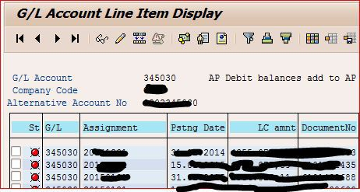

All the line items are now open Item Managed and now you can perform the clearing operation with this GL.

TCode : FS00

Here you can see that the GL is checked for Open Item Management

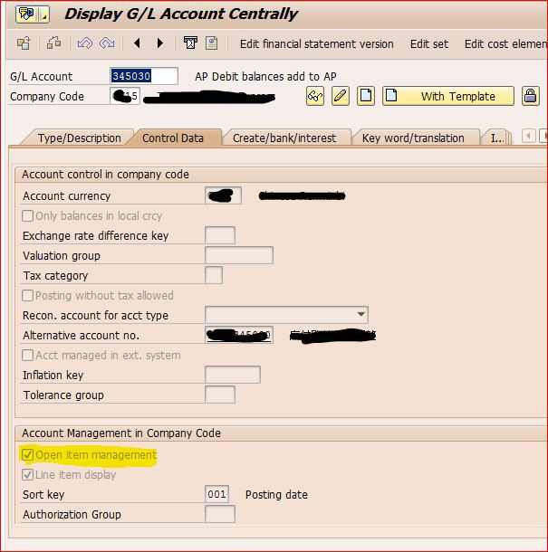

Now the Question is, **What is open item management?**  
In technical point of view it is just check box of control data tab in GL master data (FS00).Check screen shot as marked.

In Functional point of view, it controls all outstanding’s ,which will be receive from customer’s or is payable to vendor’s / Employees / Govt. authoirities etc.

In each and every line item of respective GL account reports. It should be give clear report, which line item / invoice has to be paid to vendor and received from customers. One red / Green symbol as below mentioned will be appear in standard report like FBL3N, FBL5N, and FBL1N & FAGLL03 report ,if you marked as open item management check box in GL master.

* Red symbol states those line items are still open and yet to clear
* green symbol line items states those line items are cleared.

Accounts to be managed as Open item management:-

* **Bank clearing GL accounts**: – All bank sub ledgers like Bank incoming payments or outgoing payment GL account must be select as open item management and it will be help us for bank reconcialtion purpose.
* **Payable GL accounts**:- Like wages payable, Freight payable and other tax related GL accounts like VAT payable must be select as open item management and it will be guide to FI department line item was tracking whether outstanding line items are paid to vendor’s / employees and VAT authorities or not.
* **GRIR Clearing accounts**: – You easily recognize your contingency liability status of GRIR accounts, if you activated OI management.